1. First, double-click to unzip CrealityBelt. DMG

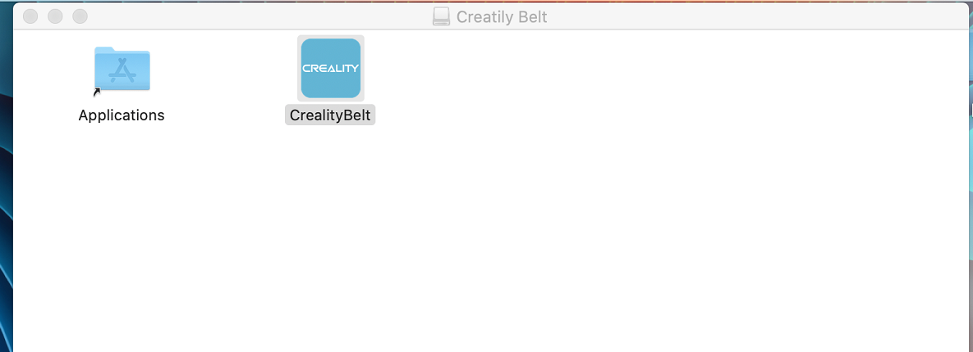

2. If you directly double-click to open the software, it will appear:

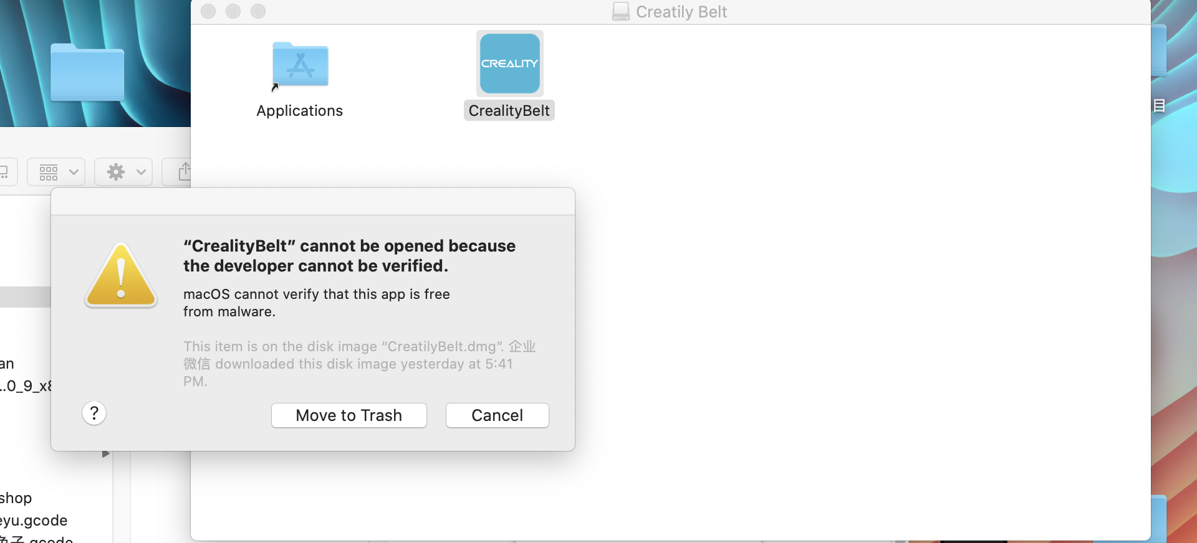

3. So first right click, then select open from the options:

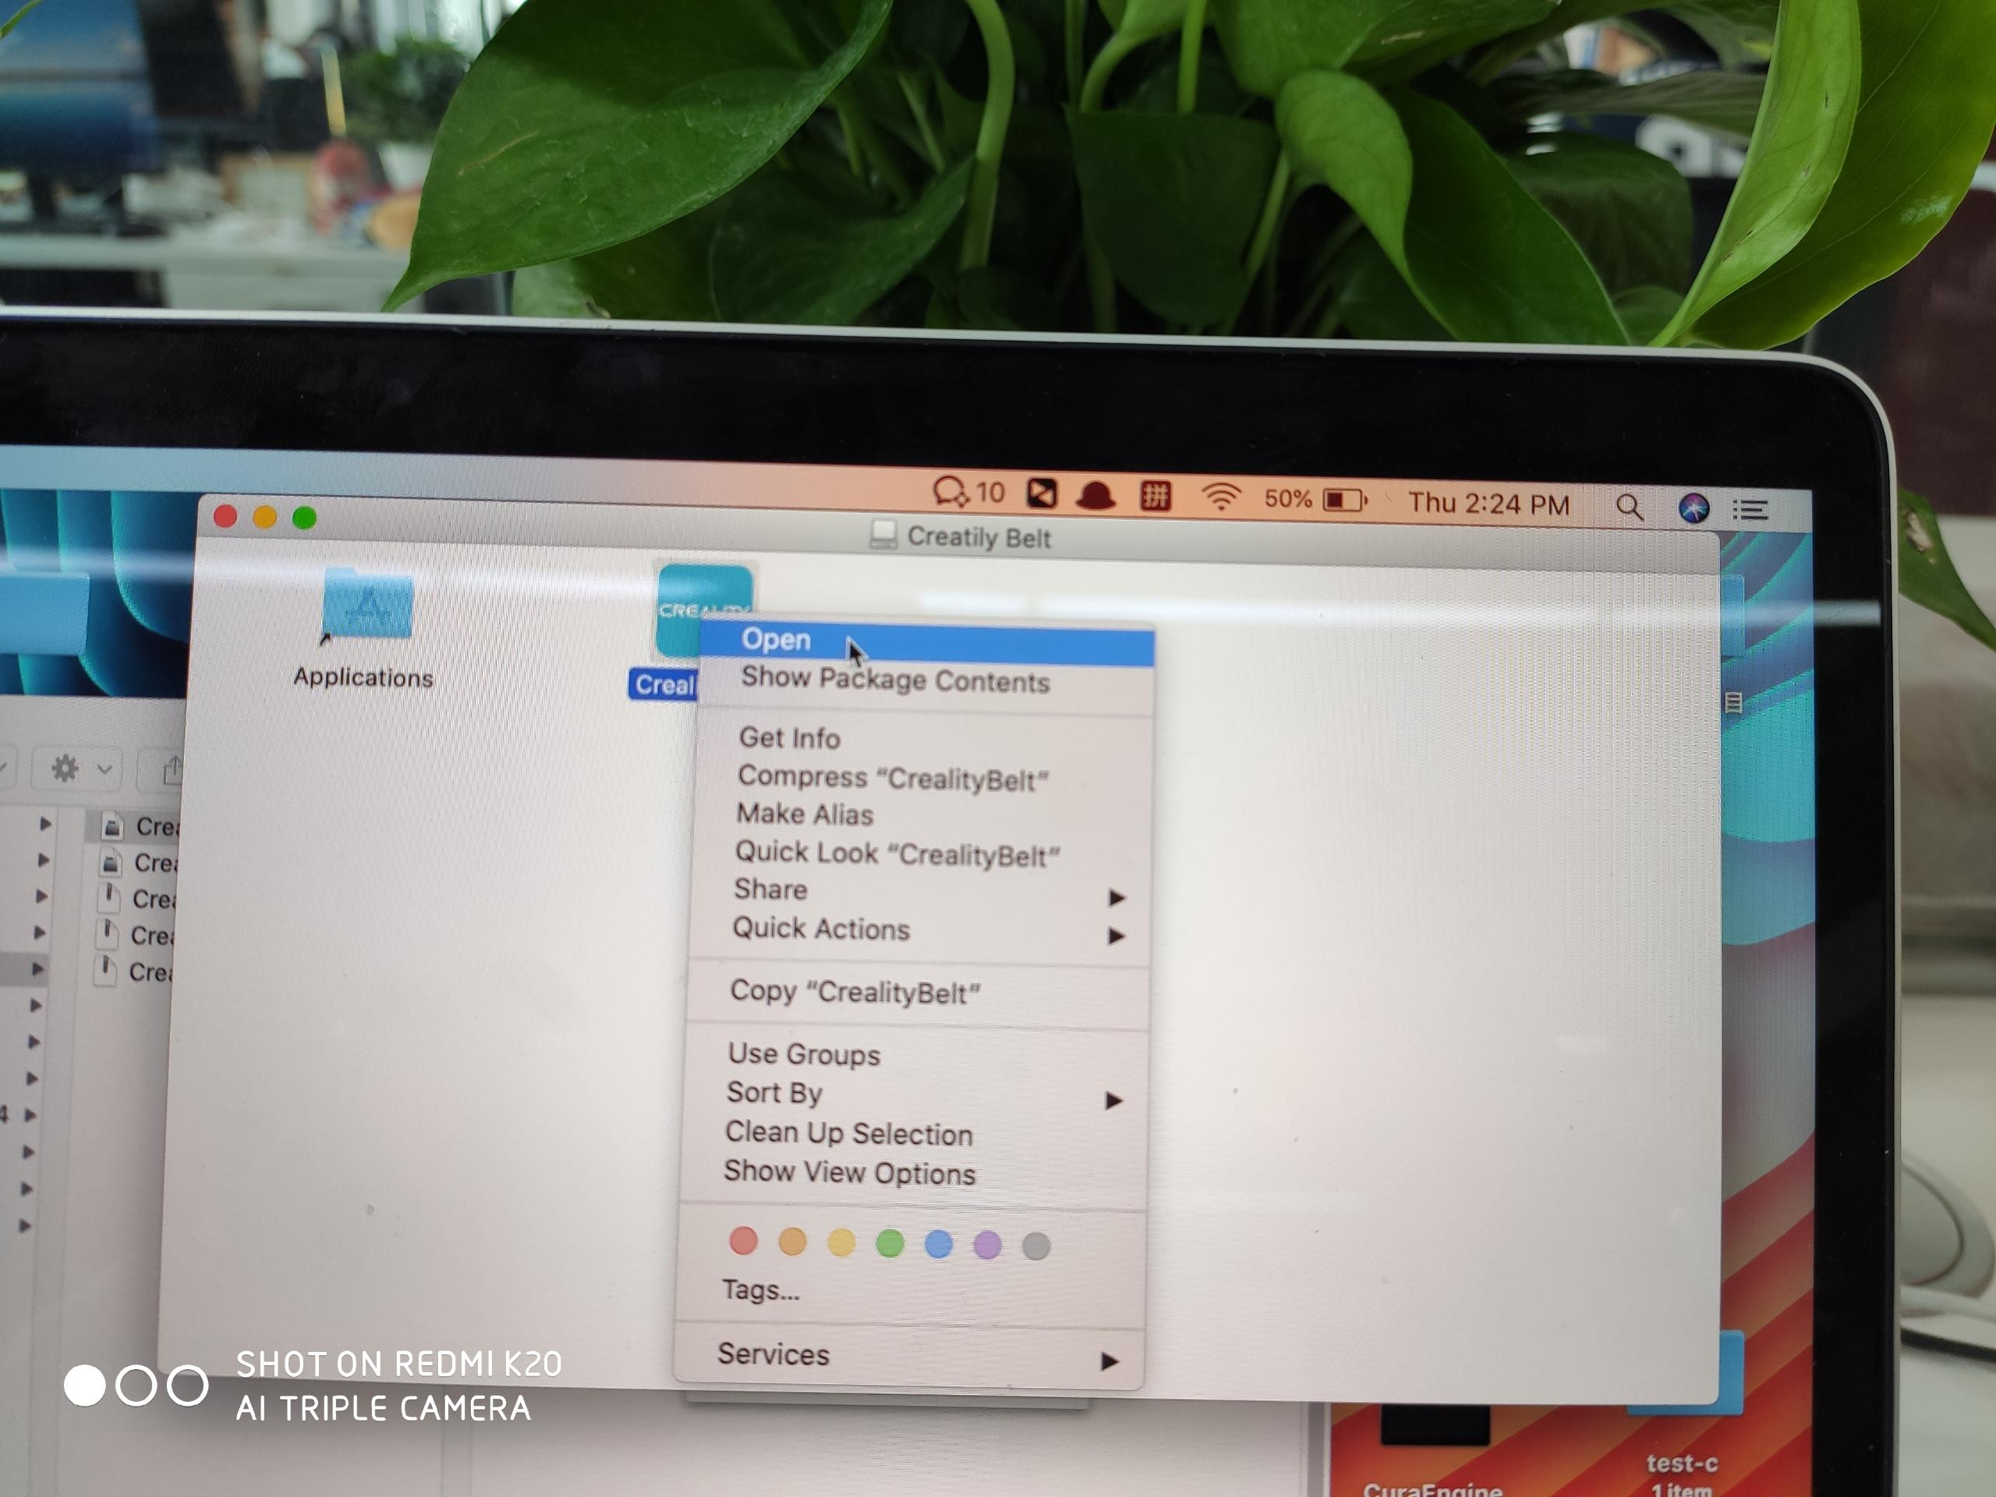

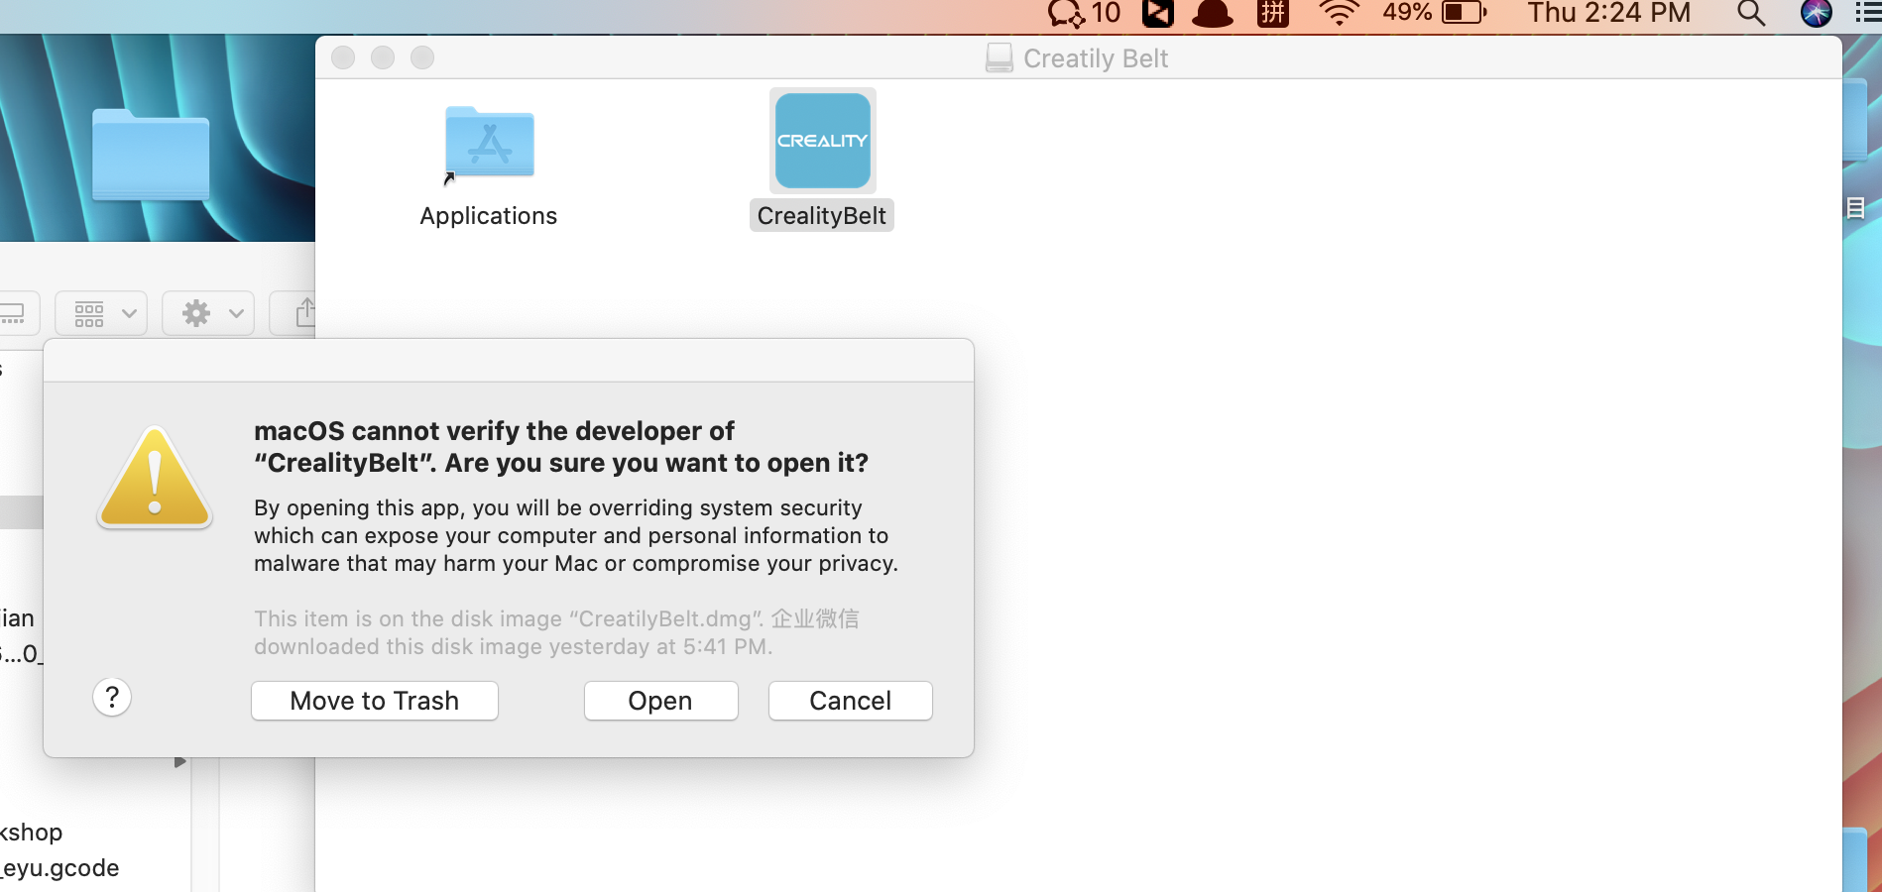

Attentions：This option is OK as long as it is opened for the first time, but it is not necessary after verification. Double-click to open it later

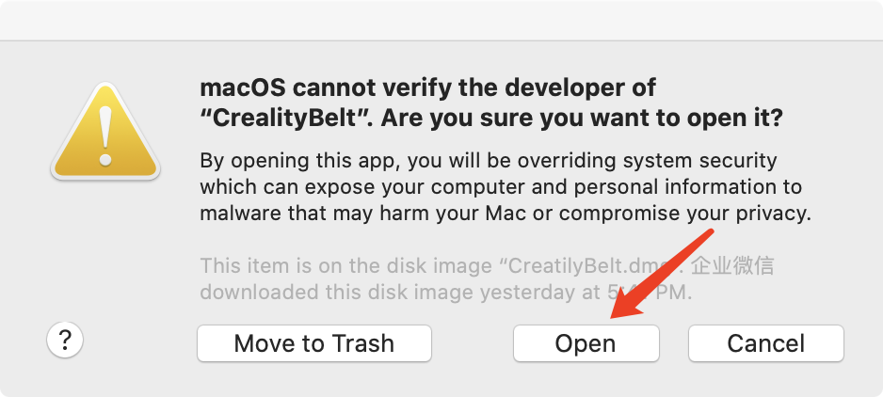

4.Open it normally

